THE PINES AT KAILUA-KONA I (“Pines I”)
GUIDELINES FOR APPROVAL OF COURTYARD
IMPROVEMENTS AND ADDITIONS TO BUILDINGS
January 9, 2017
Guidelines for Approval of Courtyard Improvements and Additions to Buildings/Jan 9, 2017 Page 1
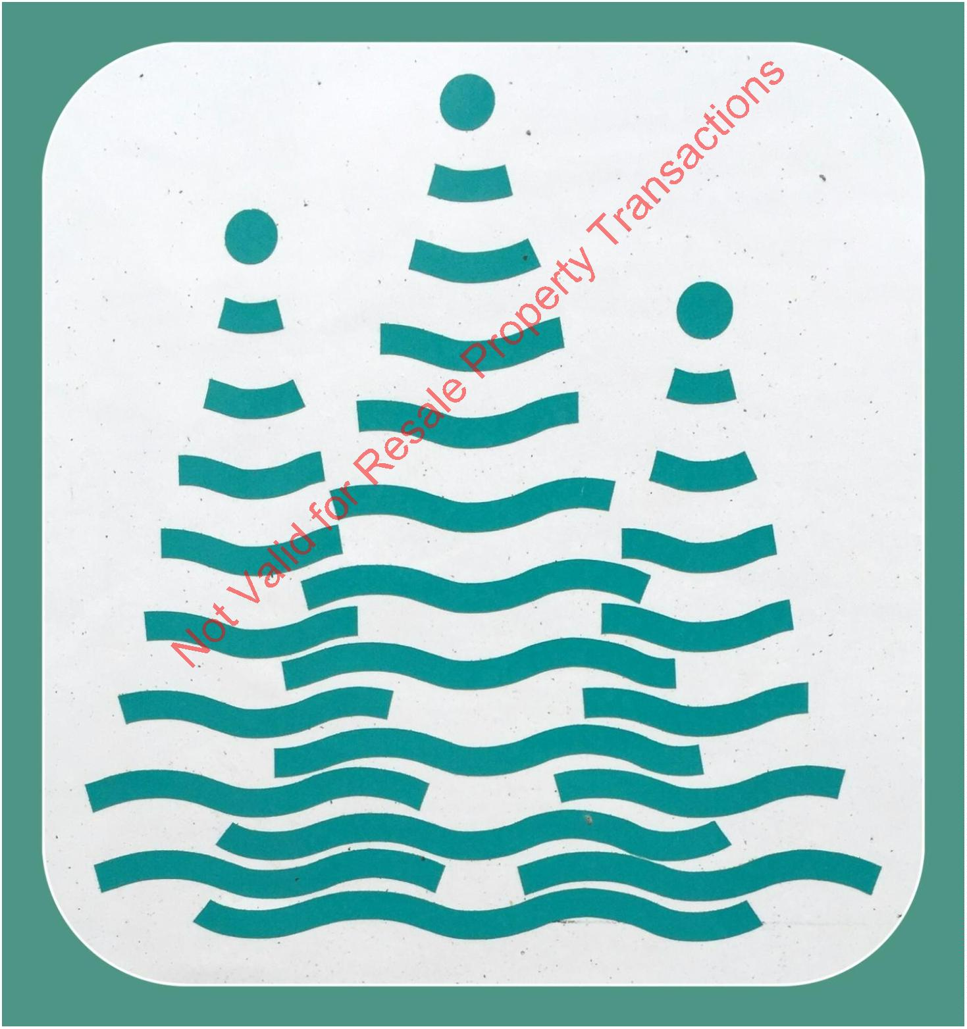

TABLE OF CONTENTS
I. OVERVIEW
3
II. IMPROVEMENT REQUEST SUBMITTAL
III. BUILDING PLAN REQUIREMENTS
IV. ARCHITECTURAL DESIGN CRITERIA
V. ZONING CODE SETBACKS
VI. LANDSCAPING
4
4
4
5
6
VII. AIR CONDITIONING
8
VIII. SCREENING
8
IX. GARAGE WINDOW
8
X. VENTS AND FANS
8
XI. RAIN GUTTERS
9
XII. SOLAR
9
XIII. DISH TELEVISION
10
11
11
XIV. MOTION SENSOR LIGHTS
XV. TELEVISION, INTERNET AND PHONE INSTALLATIONS
Guidelines for Approval of Courtyard Improvements and Additions to Buildings/Jan 9, 2017 Page 2
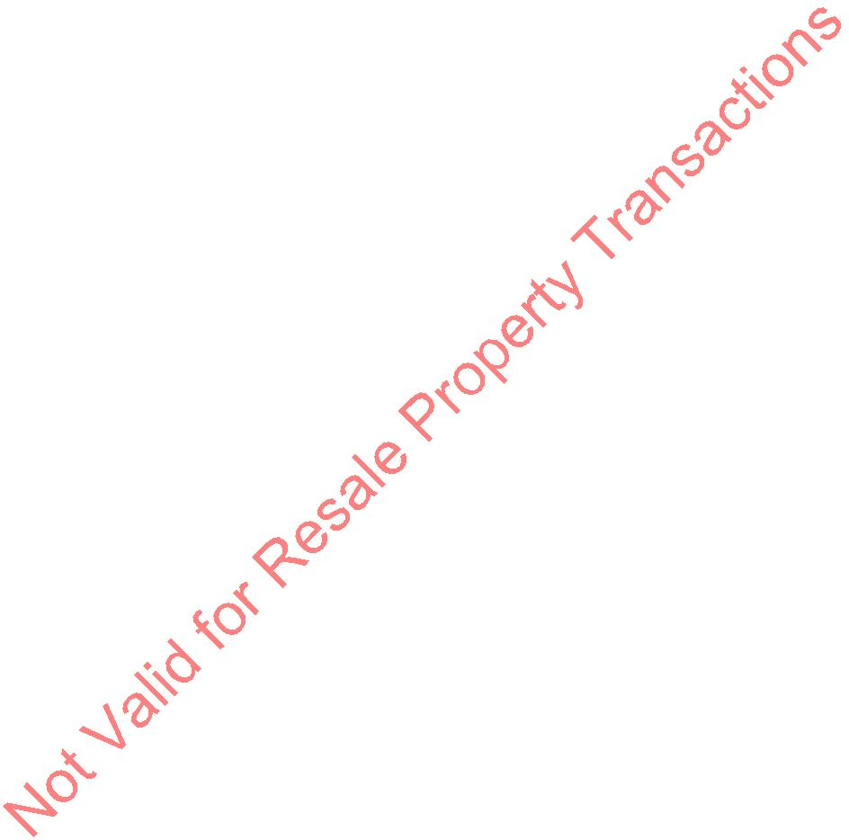

I. OVERVIEW
These Guidelines have been prepared to assist the Pines I homeowner who is planning any courtyard
or building improvements, modifications, or additions; and the Board of Directors in complying with
the Bylaws, Declarations, and House Rules for the Pines I (hereinafter to be known as the Condo
Docs). They endeavor to maintain the aesthetics of the community, including, but not limited to, a
uniform appearance of the exterior, to respect the needs and rights of others living in the complex,
and to preserve property values.
The Guidelines are not intended, nor do they constitute approval of any improvement. Each
application shall be treated on a case-by-case basis, and approval of improvements at any one unit
may not be interpreted as approval for improvements to any other unit.
In the event of a conflict between the Condo Docs and these Guidelines, the Condo Docs, as
interpreted by the Board of Directors, prevail. These Guidelines may be amended by a majority vote
of the Board of Directors at any scheduled Board of Directors meeting. There shall be no liability for
the Board of Directors for their failure to follow the Guidelines in any particular instance.
In any event the decision of the Board of Directors is final.
These Guidelines are intended to be generic signposts of acceptable improvements. They do not
constitute mandatory construction techniques or materials and are to be used solely as examples of
acceptable materials and improvements.
All improvements, and/or installations affecting the limited common elements of the condo unit or
courtyard areas must comply with the Condo Docs, these Guidelines, and must be approved by the
Board. Board of Directors authorization is required prior to obtaining the necessary County of
Hawaii Building permits, and/or beginning construction.
No construction may begin before copies of required permits and name, and license number of
contractor are delivered to the Managing Agent.
Projects with less than $1000.00 total value, i.e.: parts and labor, and that do not require County of
Hawaii permits, and that meet the requirements of these Guidelines may be performed by the owner,
or other than licensed ontractor.
Upon receipt of a complete written request for improvements the Board shall endeavor to approve or
disapprove the request within thirty days.
After notification of approval, the owner shall return a signed copy of the approval to acknowledge
acceptance of the terms and conditions specified. Meeting all conditions of the Board and any
conditions imposed by the County of Hawaii, owner may commence construction.
Upon completion of the approved project the owner shall provide written notice to the Board
(through the Property Manager) so that the Board of Directors (or Design Review Committee) may
inspect the improvements to determine that they were constructed in compliance with the approved
plans.
Guidelines for Approval of Courtyard Improvements and Additions to Buildings/Jan 9, 2017 Page 3

All improvements shall meet or exceed the uniform building codes as well as County of Hawaii
building, electrical, and plumbing codes are applicable. In addition construction techniques must
meet or exceed industry standards for preventing termite and or dry rot damage to any building
structure or fence.
All construction is to take place between the hours of 8:00 a.m. and 6:00 p.m. Monday thru Saturday.
Homeowners shall request that the contractor park in the driveway of the unit under construction.
All improvements shall be completed within six months from the date of approval. After the
expiration date, the authorization may be voided.
II. IMPROVEMENT REQUEST SUBMITTAL
All plan requests shall be submitted to the Managing Agent:
Associa Hawaii
7
5-169 Hualalai Road
Kailua-Kona, Hawaii 96740
If plans do not meet the plan submittal requirements of these Guidelines, they cannot be accepted.
III. BUILDING PLAN REQUIREMENTS
A scaled 1/8” = 1’ drawing may be obtained from the Managing Agent. This site plan or one that
depicts the as-built conditions of your unit may be used, retain the original and submit copies for
approval, other scales, such as ¼” = 1’ may be used.
Requests for approval must be submitted digitally and/or as hard copy along with detailed and scaled
drawings showing the proposed improvement, floor plan, roof plan, building elevations, (include
plumbing and electric plan if required), and section drawings that clearly describe the construction
technique employed.
IV. ARCHITECTURAL DESIGN CRITERIA
All structural improvements must be architecturally compatible in design, material and color with the
original building concept of the Pines I. The Pines I community was conceived as ‘all electric’
homes – conversion to gas for inside appliances is prohibited by the AOAO insurance provider.
The approved roof material is the asphalt shingle. The approved roof design is the gable type. End of
gable may be of lattice, or chevron design. Lanai areas must not be enclosed. Treated lumber must be
used.
Paint colors must be the same as the unit involved. Samples and numbers are posted at the mailboxes
and can be purchased from HPM.
Guidelines for Approval of Courtyard Improvements and Additions to Buildings/Jan 9, 2017 Page 4

No improvement shall be installed or erected that will adversely impact adjoining homeowners.
Notwithstanding Board approval, the Board of Directors may determine what, if any, adverse impact
has occurred, and have owners make corrections at the owner’s expense.
No improvements shall be installed or erected, the top of which is higher than the roofline of the
existing building.
There shall be no projection, of any kind, into the side yard separation between the dwellings.
Pergolas in the side yard are not allowed (a few units have grandfathered pergolas).
Concrete pads, pavers, etc. shall be kept a minimum of eight (8) inches away from the adjacent house
pad or fences.
Nonskid tiles matching or complimenting unit colors may be used to cover concrete floors, pads, or
walkways.
White plastic lattice is the only approved material to install between the ground and the bottom of the
common area fences on the courtyard side. Lattice shall not extend above the height of the fence. It
is prohibited to nail, screw or hang anything on the hardy board fence; however, lattice may be
secured by screwing into the fence post. Other materials (lava rock, stone, cement pavers) may be
located below the bottom of the fence on the courtyard side.
(Board approved August 4, 2014 updated October 13, 2014)
White plastic lattice, installed in areas other than below the fences, must have a frame.
(Board approved October 13, 2014)
V. ZONING CODE SETBACKS
All improvements must conform to the minimum zoning code setback requirements of the County of
Hawaii. As follows:
A. Twenty (20) feet on, Nani Kailua Dr., Hualalai Rd., and Queen Kaahumanu Hwy.
B. Eight (8) feet along the south property line.
If the improvement is f post and beam construction, and is considered an open projection, and when
connected to the main structure may be approved providing that a minimum of fourteen (14) feet
open clear space is maintained between the edge of the open projection and the property lines along
Nani Kailua Dr., Hualalai Rd., and Queen Kaahumanu Hwy., and eight feet open clear space along
the south property line (not the fence).
Because the distance between the end wall of each dwelling and the property lines can differ, so the
distance that a post and beam structure can project may also be different. Owners are required to
check with the County Planning Department to determine the proper setback.
Guidelines for Approval of Courtyard Improvements and Additions to Buildings/Jan 9, 2017 Page 5

VI. LANDSCAPING
Reminder: Unit owners/occupants may landscape only within the courtyard through which they
access their unit. The Association of Apartment Owners, by its contracted landscape company,
maintains all landscaping in the common area.
CAUTION: Common area plants and lawns in front of units must not be decorated, e.g., for
Christmas or Halloween, by unit owners/occupants. The common area plants are treated with
pesticides that can be harmful when absorbed through unprotected skin. The lawn areas must be kept
free for periodic maintenance by the contract landscape company.
A. APPROVAL PROCEDURE:
1
2
3
. Removal of plants does not require approval but relandscaping does. No major excavation or
planting of the courtyard areas may be done without written approval of the Board of
Directors. If there is a question if your plan is ‘major’ be sure to ask the Property Manager
for help. The Board of Directors may limit the location, size and type of all landscaping and
may specify periodic trimming requirements.
. Plans: Unit owners must submit digitally and/or hard copy their proposed landscape plans, to
scale, to the Managing Agent. The plans must show: a schedule of plant species, sizes and
number; a planting plan; and an irrigation layout. The irrigation layout must show the
location of sprinkler heads and the spray coverage. It is important to keep in mind the adult
size of plants and the trimming requirements.
. Damage: Unit owners are responsible for damage to the unit or fences caused by courtyard
improvements, which are not in compliance with these Guidelines, the House Rules or the
Condo Docs.
B. LANDSCAPE CRITERIA:
1
. Drainage:
a. Hard Surface Limitation: No more than sixty percent (60%) of the courtyard area
may be covered with concrete, brick, pavers, etc. All concrete, brick, pavers and other
hard s rfaces on the side and front courtyards shall drain toward the street away from
the unit. A slope of at least one-quarter inch (1/4”) per linear foot is required away
from the unit.
(Board approved November 2015)
b. Gutters and Downspouts: See section XI. Rain Gutters in this document for specifics.
. Wood Prohibited: Wood may not be used for landscaping.
2
3
. Ground Clearance for Unit Siding: Within one foot (1’) from the unit, the ground surface,
including bare soil, sod and the height of grass, etc., must be at least six inches (6”) below the
unit’s siding.
4
. Prohibited Species: Banyan, papaya, coconut palms, ‘Hong Kong Orchid’ and banana plants
are not permitted, due to their potential size and pest problems, e.g. mosquitoes and rodents.
Prohibited species shall be removed at the Board’s direction and at the owner’s expense.
Guidelines for Approval of Courtyard Improvements and Additions to Buildings/Jan 9, 2017 Page 6

5
6
. Fruit Trees: Dwarf fruit trees, including dwarf bananas, are acceptable, provided all fruit is
contained within the unit’s courtyard and fallen fruit is removed immediately so as not to
cause odor, rodent or insect problems. If a fruit tree causes such problems, the Board may
direct that the tree be removed at the owner’s expense.
. Courtyard Structures and Decorations: Courtyard structures and decorations including
fountains, fishponds, spas, birdbaths, bird feeders, wind chimes, etc., shall not cause odor,
insect or rodent problems or cause loud and/or annoying noise during the quiet hours between
1
0:00 p.m. and 8:00 a.m.
7
. Height, View and Airflow: No landscaping structure or planting may obstruct the view plane
from any other unit or impede airflow to any other unit.
Height limitations are:
•
front courtyard = peak of either unit
(the area enclosed between the two units bordered by the front fence and a line
perpendicular to the garage wall, along the front edge of the entry porch across to
the neighbor's unit);
•
side courtyard = eaves of either unit along the side courtyard
(the area enclosed between the two units bordered by a line perpendicular to the
garage wall, along the front edge of the entry porch across to the neighbor's unit
and a line from the back corner of the unit to the back corner of the neighbor’s
unit, excluding lanais).
•
back courtyard = peak of either unit
(the area enclosed between the two units bordered by a line from the back corner
of the unit to the back corner of the neighbor’s unit, excluding lanais, and the
back fence or rock wall)
Courtyard vegetation should be kept inside the unit's courtyard. Except palm fronds and tree
branches may extend over the courtyard fence or wall as long as they do not obstruct or
hinder access in common areas, or substantially shade common area landscaping. It is the
responsibility of the unit occupant to dispose of all palm fronds and tree branches that fall
from the unit courtyard into the common area. Also, courtyard landscaping shall not be
permitted to grow against or under the unit's courtyard fence or wall. Each unit owner shall
be responsible to insure that the unit's landscaping does not grow against or under the unit's
courtyard fence or wall. All costs to repair or replace a courtyard fence or wall damaged by a
unit's landscaping will be the sole responsibility of the unit owner. The Pines 1 at Kailua
Kona AOAO has the authority to remove offending courtyard landscaping at the unit's
owners expense.
All palms (Family Arecaceae) are exempt from trimming heights. At maturity all palm
trunks must be at least 4 feet from any unit or garage (including eaves and gutters), and at
least 3 feet from any fences or rock walls. Courtyard palms must be maintained so that all
dead fronds and fruiting bodies are removed from the tree. No palm fronds may hang over
the fences or walls into the common space that shade the common area plants, fall into the
common space or obstruct the landscapers maintaining the common space. Any palm
deemed to have outgrown these requirements will need to be removed by the homeowner.
Palms in place prior to Sept. 2015 are grandfathered in. However, any palm where the roots
Guidelines for Approval of Courtyard Improvements and Additions to Buildings/Jan 9, 2017 Page 7
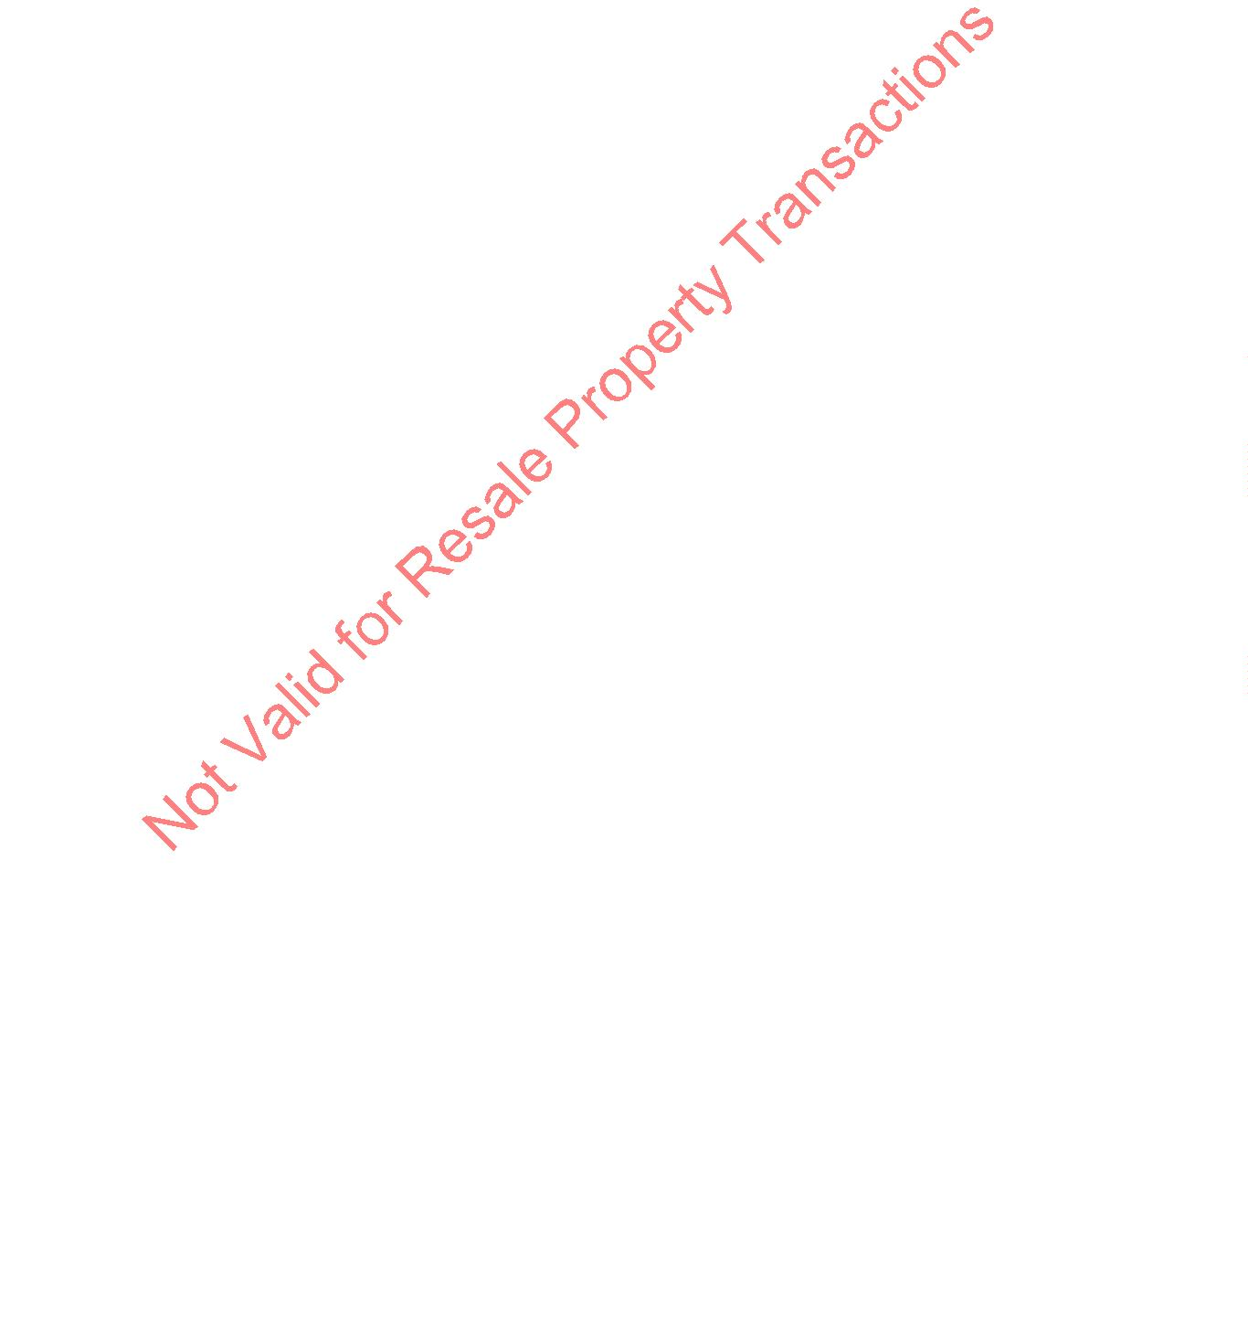

encroach on the fence, wall or unit shall be cut back by the owner away from said structures
to eliminate possible damage.
(Board approved September 2015)
C. LANDSCAPE MAINTENANCE:
1
. Trimming Required: All plantings must be trimmed to continue to comply with the
restrictions stated. Any landscaping element that outgrows its space, and/or infringes upon
any common element shall be removed at the Board’s direction and at the owner’s expense.
2
. Chemical Spraying: Spraying of herbicides, pesticides or other chemicals shall be done only
after 8:00 a.m. and only if the wind is still. Occupants of units adjacent to the unit to be
sprayed shall be notified of when spraying will be done. If the spraying causes harm,
discomfort or annoyance to occupants of other units, such spraying must be stopped
immediately.
VII. AIR CONDITIONING
A. Window air conditioning units are not permitted!
B. A plan must be submitted prior to the installation of an air conditioner. The plan must include a
brochure displaying the model, model number, and type.
C. All plumbing and electrical lines shall be routed within the walls, or chased in such a manner that
avoids exposure.
D. The AC Air Compressor shall be placed as close as possible to the unit and minimize any
unsightly exposure or noise to adjacent units.
VIII. SCREENING
A. All screened doors or windows must have white frames.
B. On plans #3 or #4, the developer provided lanai might be screened. The screen must be installed
so that it will easily open in an emergency.
IX. GARAGE WINDOW
A window similar to developer installed models, not to exceed 40”x30”, may be installed facing your
unit’s courtyard.
X. VENTS AND FANS
A. An attic vent may be installed at the top of the short protruding wall at the rear of the unit.
Guidelines for Approval of Courtyard Improvements and Additions to Buildings/Jan 9, 2017 Page 8

B. An attic vent, architecturally matching the garage vent, may be installed in front of the unit.
C. An exhaust fan, whose noise level does not disturb neighbors, may be installed. A licensed
contractor must be used to cut a hole in the roof and complete the installation. No part of the unit
may protrude above the highest roof peak, and must in all ways meet the requirements of these
Guidelines.
XI. RAIN GUTTERS
A. Approved guttering is the white seamless type, and must drain toward the front of the house and
garage, with downspouts draining inside the courtyard.
B. Gutters may be installed only upon review and approval by the Board.
C. Downspouts or chains must direct water away from the unit’s concrete pad.
XII. SOLAR
County of Hawaii building permit required for all applications. All solar applications remain the
property of the homeowner, who must accept responsibility for immediate repair, replacement, or
removal if unit threatens any common area. All solar equipment that is non-operational is to be
expeditiously removed as the responsibility of the ow er. Owner responsibility will run with the title
and it is the responsibility of the current owner to disclose to any new owner. No solar equipment
shall exceed the height of the roof ridgeline and should be placed so as to minimize any unsightly
exposure to adjacent units and common space.
(Board approved July 2013)
A. Solar Hot Water
All units must be of the flat plate design and be installed with a union close to the collector to
facilitate removal.
B. Solar Water heating panels must be placed on the garage roof, and must have connection valves
for removal of panels when roofing work is necessary. Owner is responsible for any additional
cost involved with removal and replacement of solar panels and all repairs and maintenance of
solar water heating.
C. Solar Exhaust Fans (See section X. C. for specifics.)
D. Solar Photovoltaic (PV) Electrical systems:
1
. All solar PV electrical systems must adopt the most current County of Hawaii
GUIDELINES FOR PERMITTING A RESIDENTIAL PHOTOVOLTAIC (PV) ROOF
MOUNTED SYSTEM: http://www.hawaiicounty.gov/pw-pv-guidelines.
2
. The owner shall provide the Pines I Board of Directors with a scaled drawing showing
location of major components on the property necessary to integrate the solar PV array
Guidelines for Approval of Courtyard Improvements and Additions to Buildings/Jan 9, 2017 Page 9

with the site load (building). This includes but is not limited to the solar panels, array
circuit wiring, fusing, disconnects, main panel, meter and power processing equipment.
3
4
5
. All solar equipment mounted on common elements (roofs, walls, etc.) must have
connections to facilitate removal for re-roofing, painting, re-siding, and other repairs to
the common space elements.
. All electrical lines shall be routed within the walls, or chased in such a manner that
avoids exposure. Those portions that are exposed are to be painted to conform to the
color of the house or roof.
. The only solar PV components that can be externally mounted on the common elements
(unit roof and external surfaces) are the solar panels, the emergency responder’s
disconnect switch, main electrical panel and meter. All other associated equipment,
including array circuit wiring, fusing, disconnects, monitoring devices and power
processing equipment may not be mounted externally on the common elements. All
boxes must be installed inside of the garage.
6
. The emergency responders disconnect switch shall preferably be located in the immediate
vicinity of the HELCO meter serving the unit. The disconnect switch must be accessible
to emergency personnel and be capable of being locked in an open position.
7
8
. Installation of Solar Photovoltaic (PV) Electrical systems must be installed by a licensed
contractor.
(Board approved July 2013)
. As part of the design plan submittal to the Pines I Board of Directors, the Owner and PV
contractor shall submit a signed copy of the ‘Solar Photovoltaic (PV) Electrical System
Agreement’ form (available from the Pines I Managing Agent) agreeing to comply with
the PV installation requirements (1-7 above).
E. Solar Tubes are allowed if board approved
A licensed contractor must be used to cut a hole in the roof and complete the installation. No
part of the unit may protrude above the highest roof peak, and must in all ways meet the
requirements of these Guidelines.
XIII. DISH TELEVISION
Dish Television appliances must be installed in the most neighbor friendly location possible to still
obtain service. The unit may NEVER be installed through the roof, and whenever possible must be
installed at the base of the unit within the courtyard area. By the installation of this unit the owner
understands that should the Association bear any additional costs relating to this unit in connection
with the maintenance of the common element all associated costs are the responsibility of the unit
owner.
(Board approved September 2001)
Guidelines for Approval of Courtyard Improvements and Additions to Buildings/Jan 9, 2017Page 10
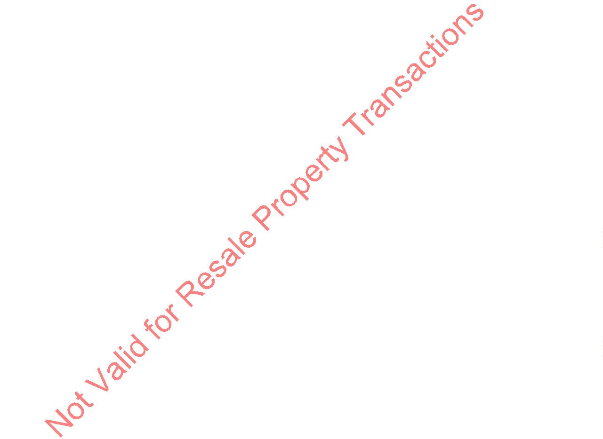

XIV. MOTION SENSOR LIGHTS
Board approval is needed for motion sensor lights.
Low profile motion sensor lights are acceptable in a white finish for wall mount only. The lights
must be directed down toward the ground so as to not infringe on any neighboring property.
(Board approved April 18, 2006 updated August 1, 2016)
XV. TELEVISION, INTERNET AND PHONE INSTALLATIONS
A. All television, internet and phone installations remain the property of the homeowners, who must
accept the responsibility for immediate repair, replacement, or removal if the unit threatens any
common area. All equipment that is non-operational is to be expeditiously removed as the
responsibility of the owner. Owner responsibilities will run with the title and it is the
responsibility of the current owner to disclose to any new owner. No equipment shall exceed the
height of the roof ridgeline and should be placed as to minimize any unsightly exposure to
adjacent units and common space.
B. TV dishes may not be mounted on or penetrate the common element roofing shingles.
C. All wiring, cabling and plumbing shall be routed within the walls, or chased in such a manner
that avoids exposure. Those portions that are exposed are to be painted to conform to color of
house or roof.
(Board approved July 2013)
Even though a criteria has been established for some applications,
Board of Director authorization for improvement must still be
obtained before any construction may begin!
Guidelines for Approval of Courtyard Improvements and Additions to Buildings/Jan 9, 2017Page 11

